This document is the project plan used by HRDEVCO to create the Rental car website for Adil co

Rental car website

Project Plan:

**Client: Adil co**

**Contractor: HRDEVCO**

Author: Hiroshi Ransom 040702761

Date: 10/03/2014

Contents

Introduction 3

Project Management Approach 3

Project Manager 3

Project Scope 3

Assumptions Constraints and Dependencies 4

Solution Options 4

Milestone List 5

Change Management Plan 5

Communication Management Plan 6

Project Scope Management Plan 7

Quality Management Plan 8

Risk Management Plan 8

Risk Register 9

Staffing Management Plan 10

Future Requirements 10

# Introduction

Adil co (the client) has given approval to HRDEVCO to commence the creation of the rental car website. The projects aim is to create a highly functional website which will allow anyone on the web to get a quote or create/manage a booking for car rental. This website will be good for the company because it saves money on staff who would otherwise make bookings manually on behalf of customers. The website will also be used to promote the opening of new locations.   
  
Included in the project plan are to be a scope statement, schedule, cost, estimate, budget, provisions for scope, resource, schedule, communications, quality, risk, procurement and stakeholder management as well as project control.

# Project Management Approach

Hiroshi Ransom the project manager will be managing the project, which includes the responsibility of managing the team, tracking the progress of the project and reporting status updates to Adil Hammadi of Adil co.   
  
The project work will be done by the HRDEVCO team consisting of 5 people, the Project Sponsor Adil Hammadi is required to approve any scope changes. All resources required for completion of this project has been provided by Adil co.

# Project Manager

The Project Manager Hiroshi Ransom is the main point of contact within the HRDEVCO team for the other 4 members. He will negotiate resources and delegate responsibilities. Hiroshi is responsible for developing the project plan, monitoring the schedule, cost, and scope of the project and maintaining control over the project by measuring performance and managing accordingly.

# Project Scope

The purpose of this project is to create an online website which will improve the companies reach to the public which will come from the exposure provided by the website. The website also provides a way to promote new locations within the business.

The website will allow anyone get a quote or create/manage a booking for car rentals. The system takes criteria from the consumer and then provides a list of suitable bookings.   
  
The client requires a login to two web portals, one for the consumer and one for the administrator.

The administrator will be able to manage the website, information such as locations, cars, consumers.

# Assumptions Constraints and Dependencies

The following list contains assumptions that apply to Rental Car Website Project. This will be reviewed and kept up to date as the project progresses.

* Training for the administration of the website will be provided
* The website will be working off Windows based machines (Windows 7)
* The website will be based on .NET technology
* The website DBMS is MS SQL 2008
* Deadline of the 23th of June 2014
* The programming team dedicated to this project has no leave during the project.
* The website must functional well with the latest browser technology.

# Solution Options

***Solution #1****:* Develop the solution in-house:   
This would involve designing the system from the beginning and developing the end solution to completely suit Adil co. If this solution is chosen, it will provide greater control over the project, it also ensures the project will meet the client’s standards. There are two drawbacks, the project timeline will be tight, and full accountability will rest with HRDEVCO.

***Solution #2****:* Modifying an existing package:  
This would involve purchasing a pre-existing system and modifying it according to Adil co specifications. By selecting this solution the feature set specified by Adil co may not necessarily be fully met. HRDEVCO has less control over quality because the work already has been done. Additional training (an outgoing expense to HRDEVCO) may be required if looking to implement advanced features or just for operation of the customised system.  
  
***Solution 3****:* Send the job offshore:   
If the job appears too large it could be an option to send the full job or parts of the job overseas for work done by programmers there. It may, but not necessarily increase a risk to quality; with good documentation and frequent communication and milestone updates the offshore work should suit the requirements.

HRDEVCO has selected solution #1. The reason for this is that by doing all the work in house it ensures the greatest likelihood of satisfying all requirements set by Adil co. The other two solutions potentially yield a greater profit while risking the quality of the product to do this and HRDEVCO does not want to risk quality.

# Milestone List

The following Gantt chart lists the major phases for the Rental Car Website project. This chart summarises the steps on gaining approval, creating the website then completing the project with client sign off. There are smaller milestones which are not included here.   
  
Scheduling delays against any of listed activities will impact a milestone or delivery date because each task is on the critical path. Should there be delays the project manager should be informed ASAP so tasks can be rescheduled in such a way to avoid any unnecessary delays. The client and team should be informed of any milestone modifications or date changes.

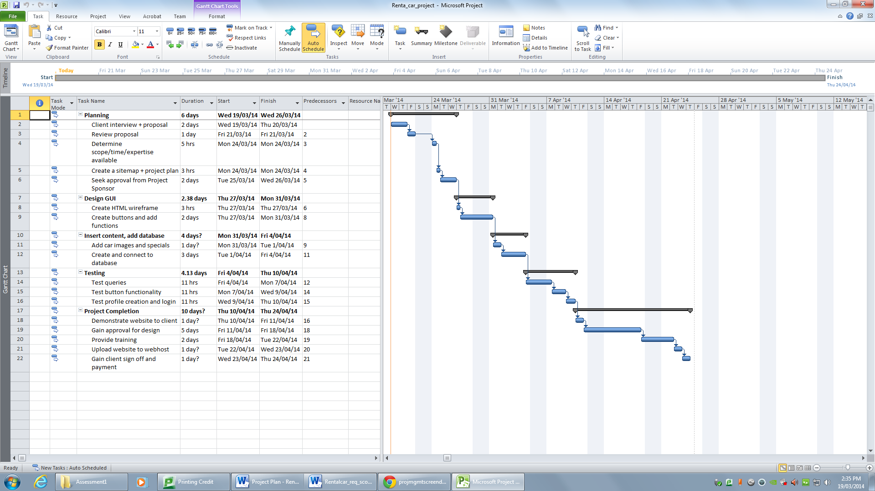

# Change Management Plan

The following is the change management process for all projects undertaken by HRDEVCO:

|  |  |
| --- | --- |
| **Step** | **Description** |
| 1 | A team member identifies a required change and then sends an e-mail or notifies the Project Manager. |
| 2 | Log the change. The Project Manager will acknowledge the e-mail/notification in a tracking file associated with the project. |
| 3 | The Project Manager evaluates the pros and cons of the desired change. |
| 4 | The Manager will either decide to either approve or decline the change. |
| 5 | Implement Change. The project plan will be altered, the client will sign off on the change and a team meeting will be held to advise the members on how to implement the change. Original project documentation will be modified as necessary. |

# Communication Management Plan

The Communications Management Plan below defines the standard team communications for this Rental Car Website project. This plan identifies and defines the roles of project team members. It helps to clarify what communication needs to happen. The Project Manager will take the lead role in ensuring effective communications on this project. Due to the short time-span for this project the communication is more frequent.

|  |  |  |  |  |  |  |
| --- | --- | --- | --- | --- | --- | --- |
| **Communication Type** | **Description** | **Frequency** | **Format** | **Participants/ Distribution** | **Deliverable** | **Owner** |
| Daily Status Report | Auto-e-mail project status of tasks | daily | Email | Project Sponsor, Team and Stakeholders | Status Report | Project Manager |
| Project Team Meeting | Meeting to review action register and status and advise of progress towards milestones | Every Fourth work day | In Person | Project Team | Updated Action Register | Project Manager |
| Email | General communication | As Needed | Email | Project Sponsor, Project Manager and Team Leaders | Varies | Varies |
| Phone Calls | General communication | As Needed | Phone | Project Sponsor, Project Manager and Team Leaders | N/A | Varies |

Project team directory for all communications is:

|  |  |  |  |
| --- | --- | --- | --- |
| **Name** | **Title** | **E mail** | **Cell Phone** |
| Adil | Project Sponsor | adil@adilco.com | 2353252 |
| Hiroshi Ransom | Project Manager | hr@gmail.com | 2323262 |
| Jacob Jacobson | Developer 1 | jjacobson@hotmail.com | 5472322 |
| Jeremy Fisher | Developer 2 | [jfisher@gmail.com](mailto:jfisher@gmail.com) | 2352323 |
| Hubert Cumberdale | Developer 3 | hubertcumberdale@gmail.com | 2784556 |
| Margery Stuart Baxter | Developer 4 | [msbaxter@hotmail.com](mailto:msbaxter@hotmail.com) | 3290902 |

**Communications Conduct:**

*Meetings:*

The Project Manager provides the agenda each meeting he is also to ensure all topics are discussed. At the end of each meeting there is an opportunity for discussion/feedback.

*Email:*

All emails in relation to the Rental Car Website Project should be professional, free of errors, and provide brief communication. The Project Manager should be included on any email which involves the project.

*Informal Communications:*

Any issues which arise during any informal communications between team members need to be documented and circulated by the Project Manager.

# Project Scope Management Plan

The project manager will monitor the quality of the project by viewing the documentation as it is updated.

Any scope changes recommended will be raised to the Project Manager who in turn will evaluate the pros and cons of the change notifying the client. When the client has accepted the change the Project manager is then responsible for implementing and documenting the said changes.  
  
The Client is to formally accept the project’s final deliverable and project scope. This acceptance is based on a review of the documentation, testing results, features and completion of the tasks/work packages according to the documentation.

# Quality Management Plan

All the members of the Rental Car Website team play a role in quality management. Therefore the entire team is responsible for the project meeting an appropriate standard in its various aspects. The following are the quality roles and responsibilities associated with the positions for the Rental car website.

The Project Sponsor is chiefly responsible for approving all quality standards for the Rental Car Website. The Project Sponsor is to review the project tasks and deliverables ensuring they meet or exceed the functional requirements and are compliant with established and approved quality standards. The Project Sponsor having reviewed these things will then sign off on the acceptance of the project.

The Project Manager is responsible above the Development team for quality management throughout the duration of the project. The Project Manager should implement a Quality Management Plan proactively while the project is being undertaken. On completion the Project manager should review all tasks, processes, and documentation to ensure they are compliant with the plan. The Project Manager is also responsible for communicating and tracking all quality standards to the project team and stakeholders.

The Development Team is responsible for maintaining code quality and ensuring the application meets the standards described in the plan. In order to make the project become what it needs to be, there should be a review process in place, and the team should maintain a testing schedule providing information to the project manager as it becomes available.

# Risk Management Plan

The Rental Car Website project team has a risk management process. The team members determine the risks, rank them and then describe possible steps to reduce the likelihood/severity of the risk.  
  
Every effort will be made to identify risks ahead of time for better preparation should the risk occur. The project plan will take into account likely or high impact risks and has extended time added to tasks to factor in the possibility of risks occurring which allows the Project Team to have a margin for error. As part of any status reports, any changes to the risk register will be distributed.

When the project has been completed the Project manager is to assess how the project tracked against the project plan and where risks occurred, taking note on how the team could improve with regard to risks for the future.

# Risk Register

|  |  |  |  |  |  |  |  |  |  |
| --- | --- | --- | --- | --- | --- | --- | --- | --- | --- |
| **Risk Identification** | | **Qualitative Rating** | | | | | **Risk Response** | | |
| **Risk** | **Risk Category** | **Probability** | **Impact** | **Risk Score** | | **Risk Ranking** | **Risk Response** | **Trigger** | **Risk Owner** |
| Staff may not be available to work on the project for a variety of reasons. | Schedule | 3 / 10 | 7 / 10 | 21 | | 1 | Workload should be taken on by another team member | Sickness or other commitments. | New task owner |
| Additional development required for website functionality | Usability/  Schedule | 2 / 10 | 9 / 10 | 18 | | 2 | Project Manager to discuss/re-negotiate requirements or work load | Client requires different functionality | Project Manager |
| Big Issues found during Testing | Usability/  Schedule | 2 / 10 | 9 / 10 | | 18 | 3 | Need to set a new deadline for delivery of the project. Testing continues until all issues have been resolved | Major Issues found during Testing that require more time to correct | Project Manager/Stake holder |
| Lacking skills for system build | Schedule | 2/ 10 | 8 / 10 | 16 | | 4 | Seek specialist for work or undertake required training | Lack of knowledge | Project Manager |
| Technology being used wont provide the functionality in the plan | Schedule | 1 / 10 | 9 / 10 | 9 | | 5 | Immediate meeting to discuss new approaches | Technology issues | Head of Development Team |
| Power Failure | Schedule | 2 / 10 | 2 / 10 | 4 | | 6 | Work must be continued at home or on laptops | Power failure in the office. | Entire Development team |

# Staffing Management Plan

*Project Manager (1 position):* Responsible for the management for the Rental Car Website project. The Project Manager is responsible for planning, creating, and managing all work activities. He/she will manage or monitor variances in the project to the plan, reporting progress, performance evaluations against timeline, and staffing.

The Project Manager will be compiling all project documentation, capturing and distributing minutes of meetings and ensuring documentation meets appropriate standards.

*Development Team (2 positions):* The Development Team will design, code and test the project to ensure it meets the standards set by the client.

# Future Requirements

The Rental Car Website Project is to be implemented as per the requirements outlined within the scope of project document and signed off by the Project Manager and the Project Sponsor.

Possibilities for future requirements and potential enhancements may be identified as the project progresses. Here are some future possibilities with new enhancements added as they are realised.

1. Share and like buttons for social media can be added very easily at minimal cost.
2. Advertising space may be sold to other companies increasing revenue from the website.
3. Website could feature an online chat system for people seeking help regarding their booking.